GrayJay Officials Guide for RIC’s

Users with Referee-in-Chief (RIC) permissions for a league or association will have access to the GrayJay Officials workspace, which allows them to manage the officials (referees and timekeepers) who will be working games in the league/association. RIC access allows the user to do the following:

- Invite officials to create a GrayJay account and/or grant permissions for officials to see and be assigned to the games scheduled within your league or association.
- Setting the qualifications per official to specify which roles (referee, linesman, or timekeeper) they are qualified to work on a per league basis.
  - For example, an official may be qualified to be a linesman for U15AA and below, but only qualified to be a referee for U13AA and below.
- Configure pay rates per role per league.
  - For example, a referee for a U18A game earns $x per game while a linesman earns $y per U18A game.
  - This feature is currently limited to associations.
- Record adjustments or payments per official.
- View and manage incident reports.
- Manage the recipients of automated incident report emails.
- Assign officials to games scheduled for the league or association (games where your association is the home team or where your association has been specified as the “home team association”)
  - The Assign Officials page will list all games for which you are responsible to assign officials. The officials presented as options per game and per role will be based on the availability of the officials (as set by the officials) and the qualifications of the officials (as set by the RIC).

Setting Permissions & Qualifications for Officials
The first step to building your roster of officials for your league or association is to invite officials to create a GrayJay account with permissions for the league or association. The same steps outlined below will grant permissions to the league or association if the official already has a GrayJay account.

- Login to grayjayleagues.com with an account that has RIC permissions for the league or association.
- Go to the Officials menu.
- Click Add User.
- Enter the email address for the official.
- Select Referee and/or Timekeeper for the league(s) and/or association(s) for which the logged in user is a RIC.
- Click the Invite button.
- Specify the qualifications for the official by selecting the role(s) and the league(s) in which they will be allowed to work. Note that the list of leagues presented in the list is based on the teams that exist in your association.

Configuring Pay Rates
For associations, users with RIC permissions can configure the pay rates per league and per role. The system will then generate reports showing the $ amounts earned per official based on the games they have been assigned to.

To set pay rates, go to the Payment Settings menu under the Payments section and enter the values per league and per role. You must also specify an effective date, which allows you to modify the pay rates at any time without impacting games worked previous to the new effective date.

Note that the list of leagues presented in the list is based on the teams that exist in your association.

The following reports are available:
- Summary Report: A list of all Officials in your association and their current balance ($ earned plus any adjustments less any payments or negative adjustments).
- Official Report: A detailed list of all games worked per official. This report also shows any payments or adjustments in chronological order.

Recording Adjustments & Payments
The payment reports show the amount earned per official based on the games they have worked and the pay rates configured per role and per league. As a RIC, you can enter adjustments and payments for the official or for a specific game for the official.

An adjustment can be entered to adjust the pay earned for an official, and can be entered as a general adjustment for the official or as a specific adjustment to a specific game. Adjustments are intended to accommodate cases where the configured pay rate does not cover the situation. For example, if an official needs to be reimbursed for gas based on travel time, an adjustment can be entered, with an accompanying note, to add a $ amount for gas. Adjustments will be added to (or subtracted from if the adjustment is a negative amount) the total pay earned by the official.

A general payment can be entered as a new line item with a date and a note, similar to adjustments, or you can enter a payment specific to a game to capture cases where an official is paid cash at the time of the game, for example.

Pay information is exposed to individual officials so they can see their history of games worked, $ earned per game, payments, adjustments, and an overall balance, so it is important that you enter any payments you may have already made. Otherwise, the balance exposed to the officials will not be accurate.

To add a general payment as a new line item, click Payments -> Official Report and select an official, then click the Add Payment button. Enter the date of the payment, the payment amount, and a note (optional). A new line item will be added to the report showing the payment, and the official’s overall balance will be updated to reflect the payment.

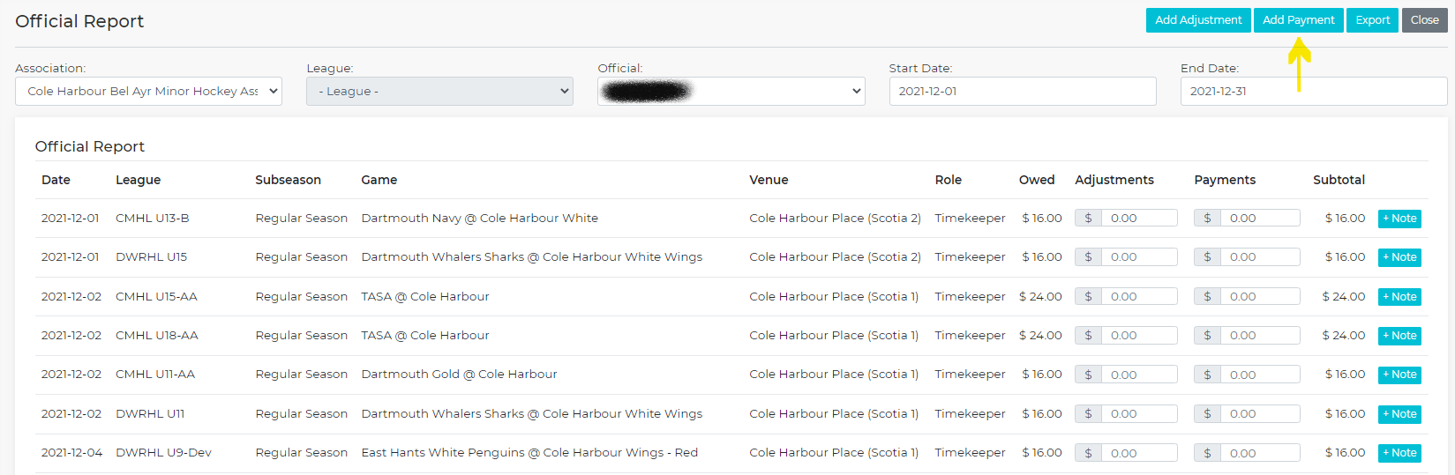

To add a game-specific payment, click Payments -> Official Report and select an official. Enter game-specific payment(s) in-line by editing the value in the Payments column, as shown below. The official’s overall balance and the subtotal for that specific game will be updated to reflect the payment.

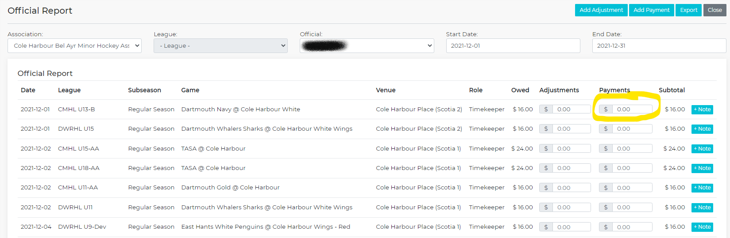

Incident Reports
If a game requires that an incident report be filed, the referee can add the incident report to the game record via the GrayJay Officials workspace. To do so, the referee must navigate to the game and click the Incident Report button as shown below. If there is already an incident report (or multiple incident reports) associated with the game, a badge showing a number will be displayed as shown below.

The referee can either view the existing incident report(s), or add to the incident report if it has not yet been finalized and sent.

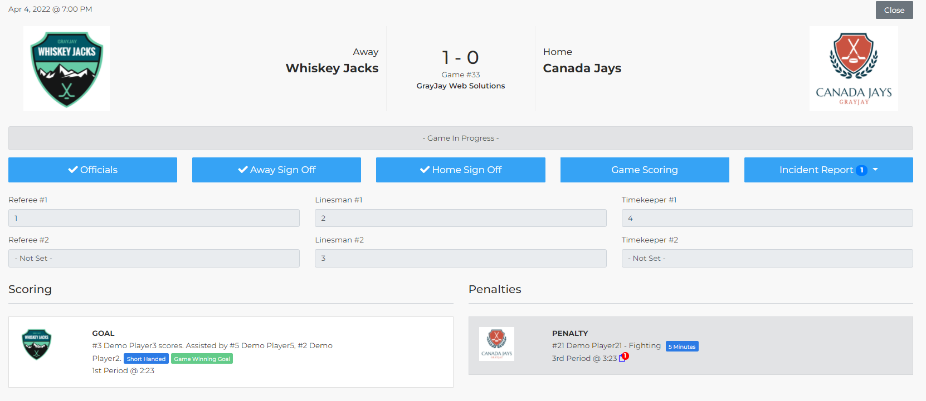
When adding an incident report, if the game has been scored in the system such that the penalties have been entered, the referee can select the penalty or penalties associated with the incident report. This will auto-populate the specifics for the penalties (player name, player number, time of the penalties, period, infraction, rule number(s), etc..

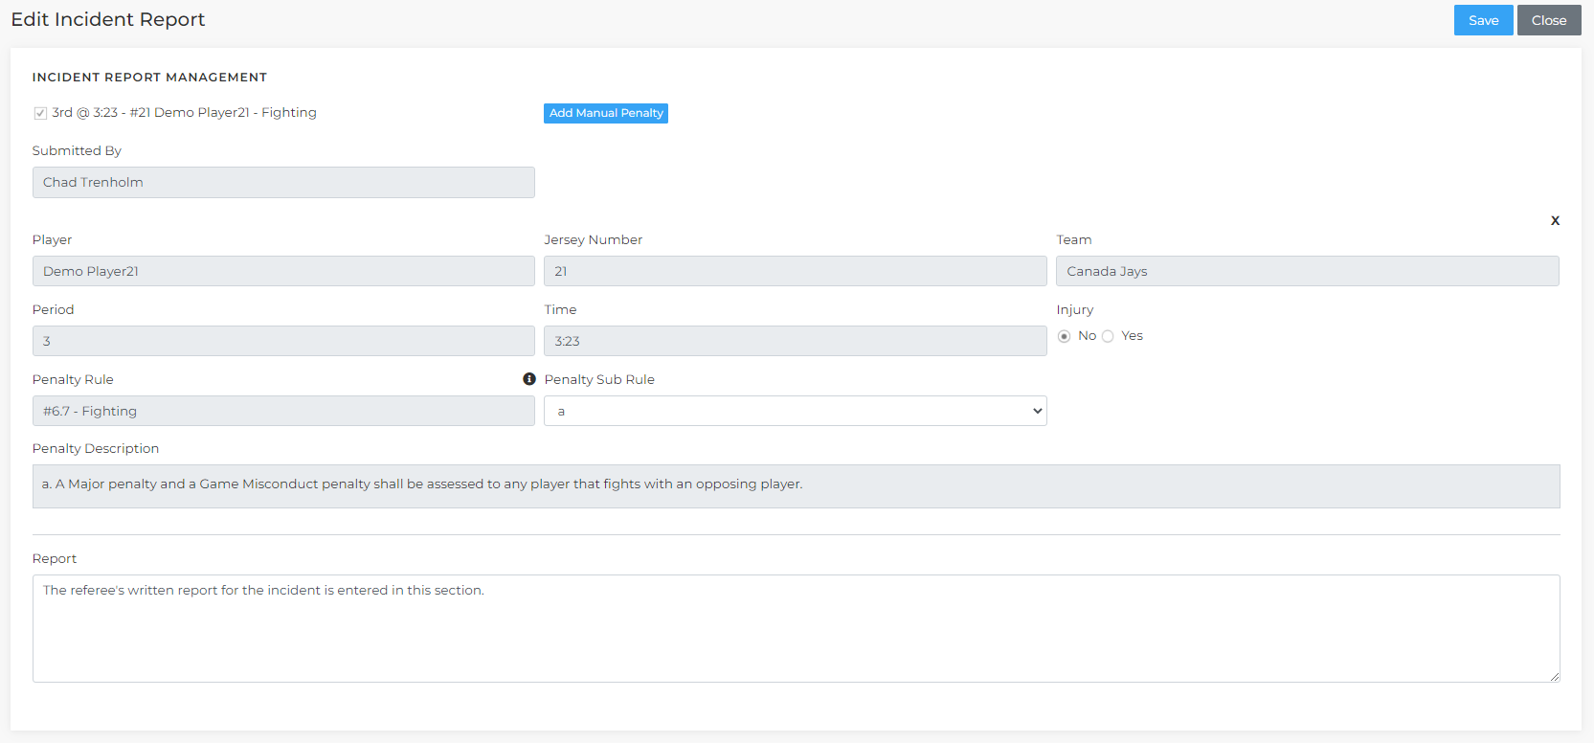

The referee can write their report in the Report section at the bottom of the page, and when completed, click the Save button. When all incidents have been added, the referee must click the Send Incident Report button to file the report and initiate emails to the appropriate recipients.

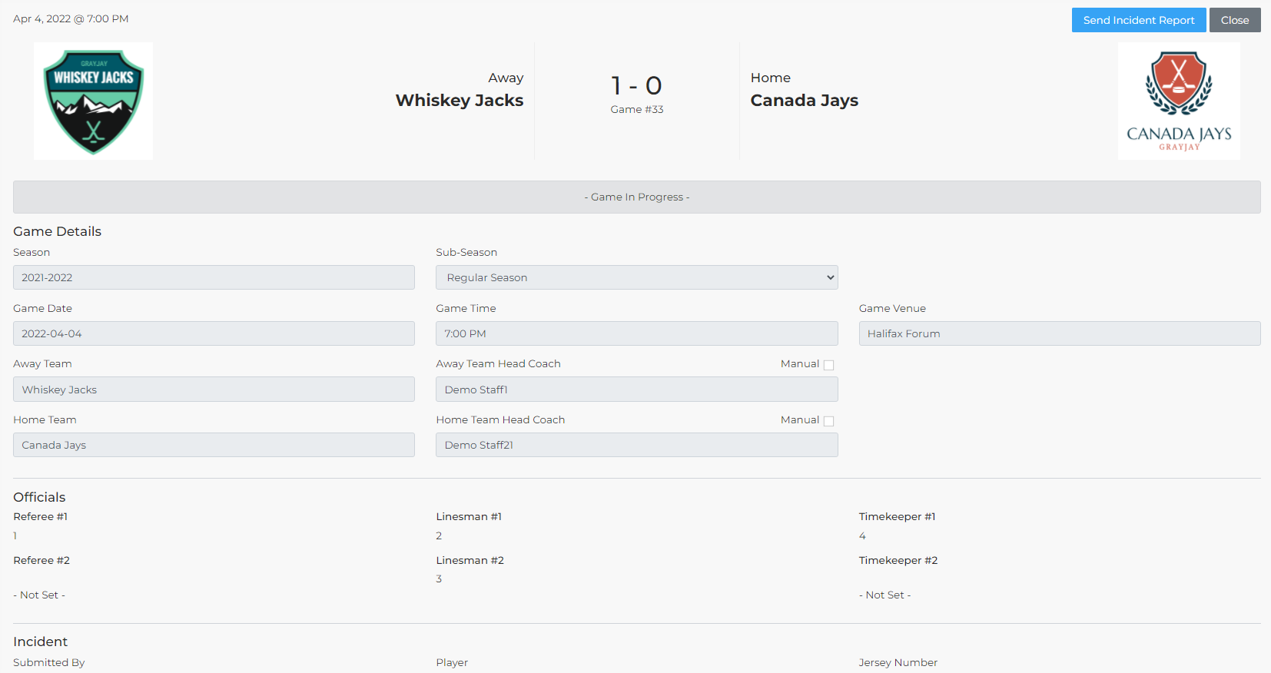
The RIC’s for each league/association will automatically receive email copies of the incident reports filed for games in the league and/or association. League RIC’s can configure additional recipients of automated incident report emails by going to the Settings menu and entering the email address(es) of the intended recipients. If entering multiple email addresses for a given league, separate the email addresses with a comma.

Assigning Officials
The Assign Officials page will list all games for which you are responsible to assign officials. The officials presented as options per game and per role will be based on the availability of the officials (as set by the officials) and the qualifications of the officials (as set by the RIC).

A few things to note based on the screenshot below:
- There is a Customize option (circled in the top right below), which will allow you to select which columns you want to see. For example, if you don't assign timekeepers you can hide those columns if you wish. If you want to see the game numbers, you can add that column. Your selections should be remembered each time you visit this page.
- There is a little calendar icon beside each selection box, which will be linked to the selected official's calendar view showing his or her availability and assignments.
- Games where the date, time, or venue are marked as TBA are not included on this page.
- You can set the page to show 25, 50, or 100 rows.
- Some fields will show as grey instead of white when they are not yet assigned. This is based on the settings for that league (ie U15A, U13AA, etc.) regarding the minimum officials required per role and this is the same logic that system enforces during pre-game sign-off. For example, if a league is set to require only one referee, two linesmen, and one timekeeper, then the Referee 2 and the Timekeeper 2 boxes will show as grey if not assigned.
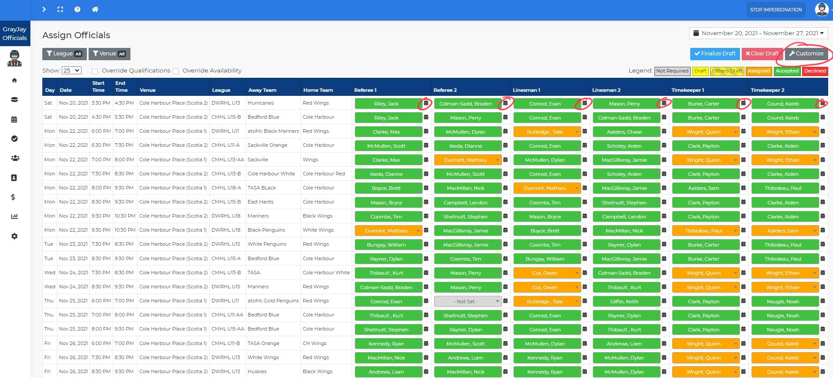

One other thing to note in my screenshot above is that the left menu has been collapsed/minimized. To do so, you can click the icon I have circled below. This icon isn't necessarily obvious, so we will be adding something to make it more apparent that this option exists.

Managing Availability & Assignments in GrayJay Officials
Please view our 2-minute tutorial video for officials about managing availability and assignments in GrayJay Officials. For referees, it is important to set your availability to ensure that you can be assigned to games. We have noticed that some officials are setting their availability in 30-minute chunks, but you will see in the video that you can simply click and drag to set larger chunks of time.
For timekeepers, while this same functionality is supported, it depends on whether or not your league(s) and/or association(s) are using the assignment feature for timekeepers. If a timekeeper is not assigned to a game, but has permissions for a certain league or association, they can select "All Games" on the Games page to see games for which they have not been assigned and this will allow them to score those games.

Combined Availability View
Under the Reports menu there is an Officials Availability option. You will see a list including all of your officials by association (league filter is not yet available), and their hourly availability per official. See below for an example (note that the names have been faded out in the screenshot).

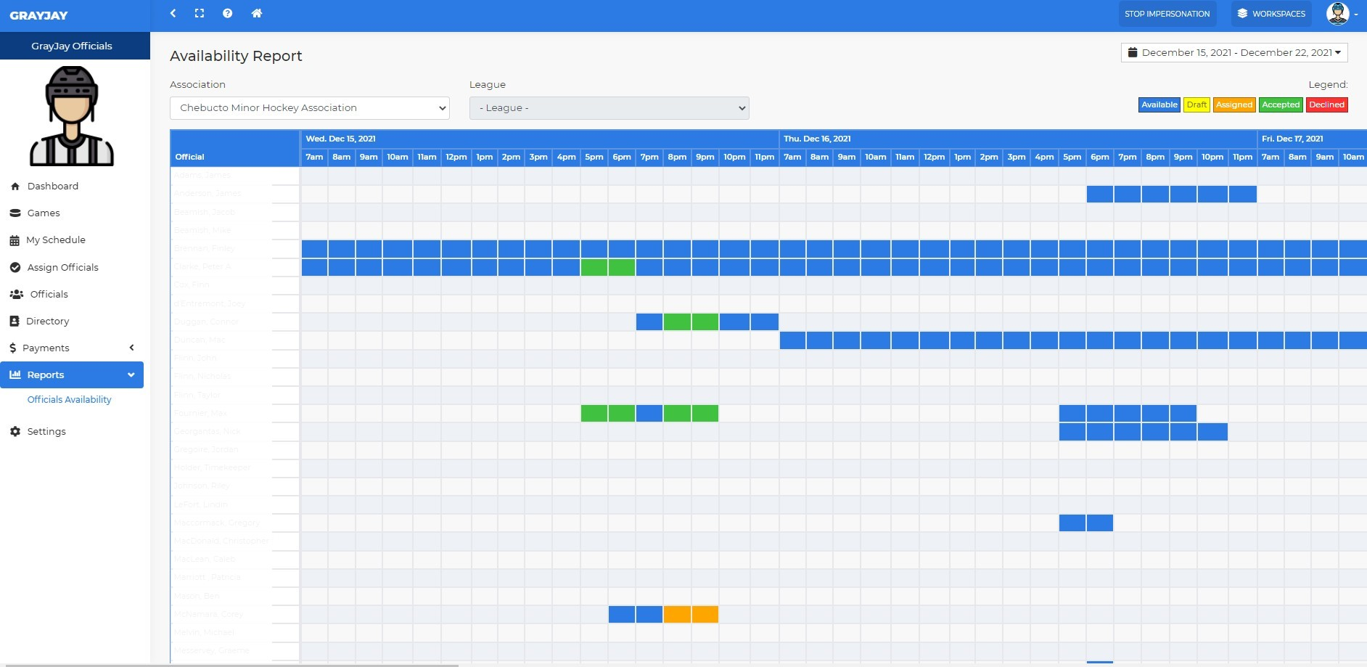

My Schedule and Webcal Subscriptions for Officials
A few new enhancements have been made to the GrayJay Officials system! You will see more information included on the dashboard under the Pending Assignments section for officials. We now show the role assigned (Referee, Linesman, or Timekeeper), along with the game #, teams, league, time, date, and venue. There is also a new button that will link you directly to the game page:

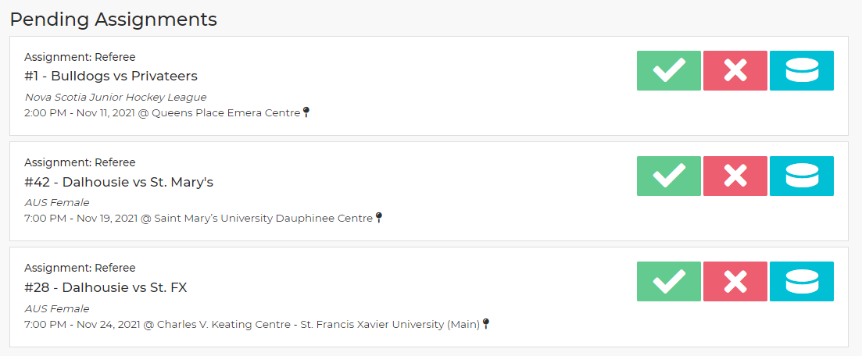

My Availability has been renamed to My Schedule and we have added a Subscribe button in My Schedule to allow officials to subscribe to a webcal calendar (Internet calendar) showing their personal schedule of assigned games, including accepted and assigned games:
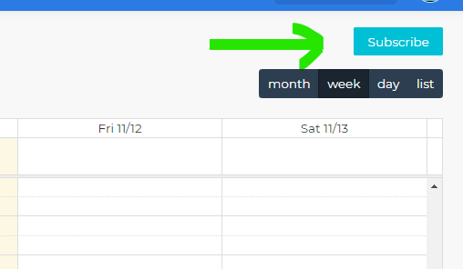
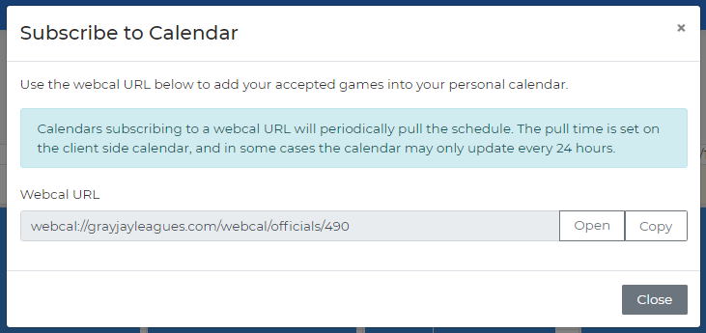

It should be noted that webcal updates are not "pushed" to your device but rather your calendar client will "pull" updates at some interval, which may or may not be configurable, depending on the calendar client you are using.

Officials Directory
This Directory view lists all officials who have the same permissions as you. For example, if you are an official or a RIC for Minor Hockey Association "A" and League "B", then you will see all other officials and RIC's for Minor Hockey Association "A" and League "B".

You are in control of whether or not you want your phone number or email address to be displayed, and this can be set under your profile, which can be found in the top right portion of your screen when you are logged in.

There are also filters available to help you narrow the list. See below for a screenshot, and notice that there are icons to create an email or start a phone call. If that information has not been provided or if it has been hidden by the user, the icons will be greyed out. The screenshot below shows a few of my test accounts.

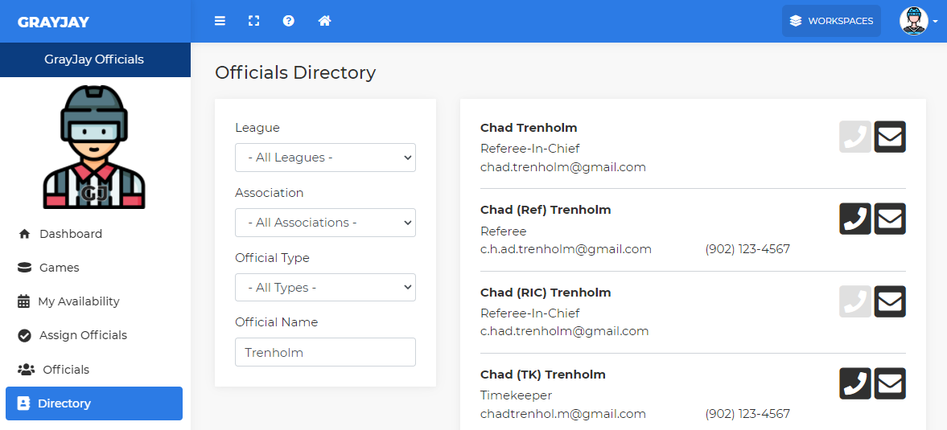

On a mobile device, the view will be like the screenshot below, and notice that another icon appears to generate a text message to the user, if their phone number has been shared.

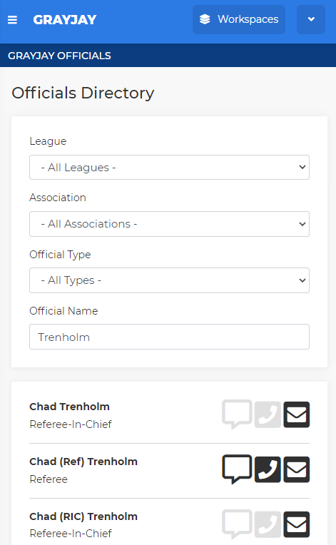

For RIC's, this view will be enhanced in the near future to allow creation of a bulk email to all selected officials.

