GrayJay Leagues Timekeeper Guide

Scoring a game with the GrayJay Leagues system has been designed to be very intuitive and can be completed on any smartphone, tablet, or computer with an Internet connection. A mobile app will be developed in the coming months to allow offline scoring in arenas with no WiFi or cellular data coverage.

Game scoring is completed in an Internet browser by following the steps below.

- Login to the GrayJay Leagues admin portal by clicking Admin Login on the website, or by visiting grayjayleagues.com.
  - A GrayJay timekeeper login account is required. Association or League administrators can invite timekeepers by email from the admin portal.
- Select the game you are scoring, and confirm that all pre-game steps have been completed.
  - Officials: The names of the referees, linesmen, and timekeeper(s) must be entered for each game before the game can be started. If the league or association is using the GrayJay Officials module to assign referees and/or timekeepers, the Officials tab will show “Assigned” when the assignments have been made. Otherwise, the names can be typed in to satisfy the pre-game requirement of having officials assigned.
  - Away Sign Off: The away team must confirm their roster for the game, specifying which players will be playing, which goaltender will start the game, and which of the team staff will be on the bench. Team staff and/or timekeepers can complete this step, but the intent is to have team staff complete this step and provide a signature.
  - Home Sign Off: The home team must confirm their roster for the game, specifying which players will be playing, which goaltender will start the game, and which of the team staff will be on the bench. Team staff and/or timekeepers can complete this step, but the intent is to have team staff complete this step and provide a signature.
- When all pre-game steps have been completed, the Game Scoring button will become active, allowing you to start the game. See additional details on subsequent pages about game scoring.
- At the completion of the game, it is important to ensure that shots per period have been recorded (if your league is tracking shots on net and goaltender statistics).

More details about game scoring are included below for reference.

Game Scoring

When all required pre-game tasks have been completed (game details, official assignments, and roster sign-offs), the check marks appear beside each task and the Game Scoring button becomes available.

Click here to see the GrayJay Leagues game scoring video tutorial.

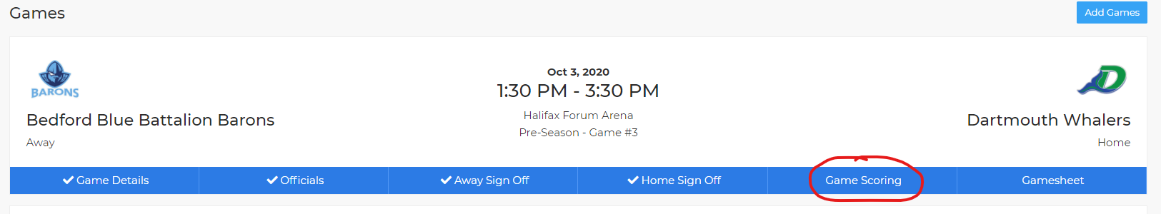

Click Game Scoring to start the game and then click Start Game to lock the rosters and allow the game to be scored in the system.

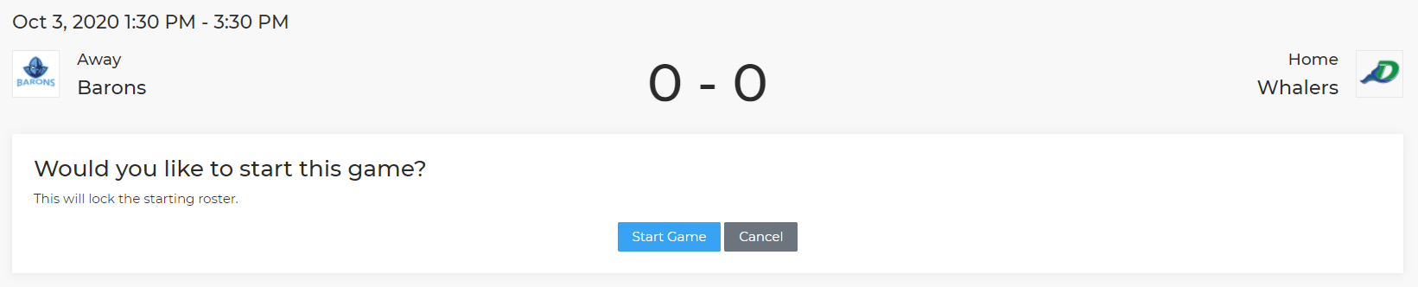

Adding Goals

To add a goal, click Add Goal, select the appropriate team, and then specify the period, time (as shown on the clock), goal scorer, assists (if applicable), and the goal type (even strength, power play, etc.), and then click Finish to save the goal. The details of the goal are published immediately to the public website game summary.

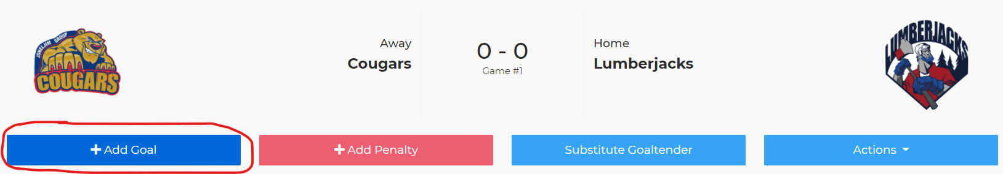

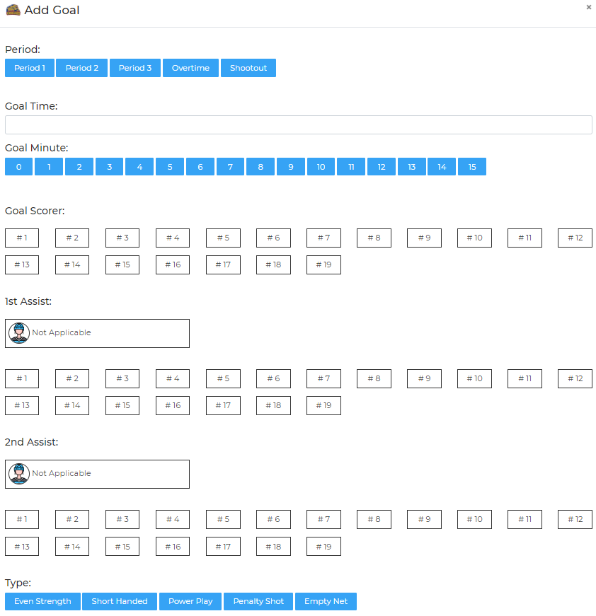

Mobile view:

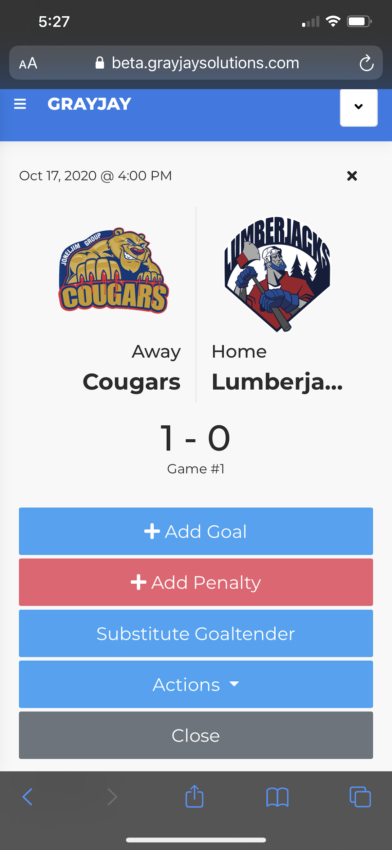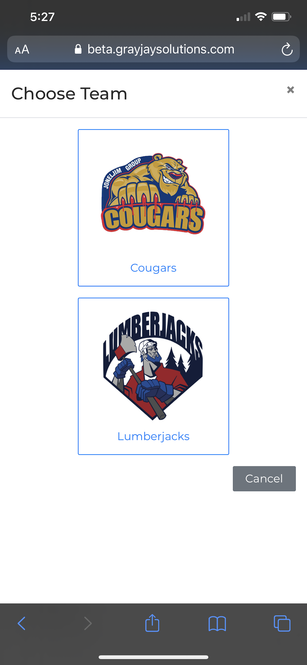
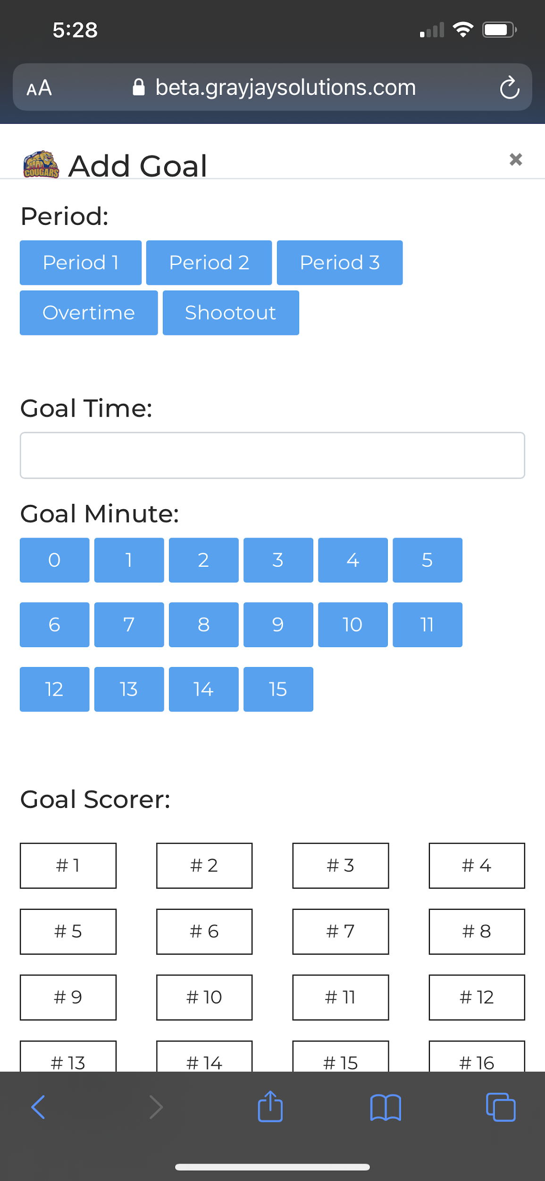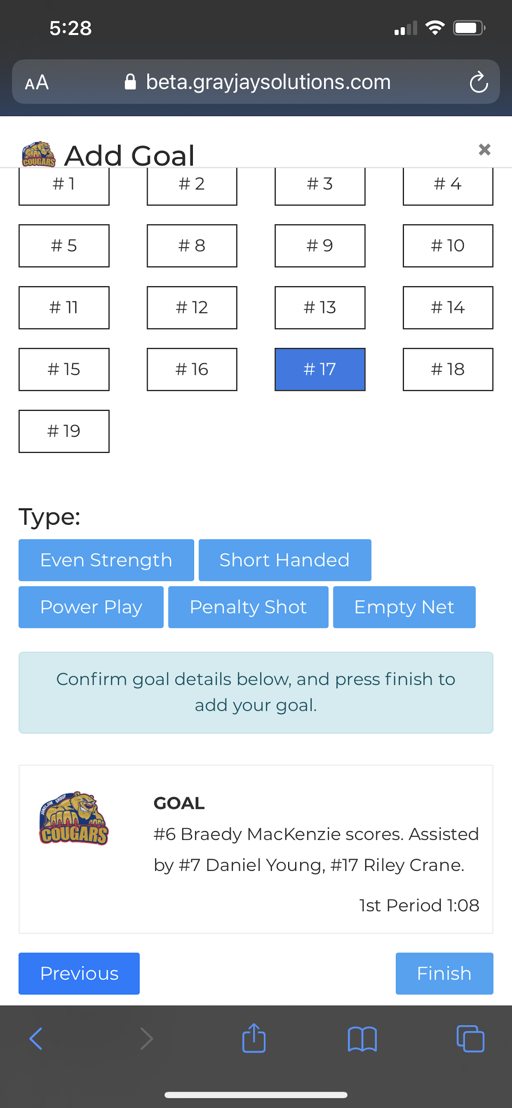

Adding Penalties

To add a penalty, click Add Penalty, select the appropriate team, and then specify the period, time (as shown on the clock), infraction (sorted by most common infractions), confirm the length of the penalty, and specify the player serving the penalty (if applicable), and then click Finish to save the penalty. The details of the penalty are published immediately to the public website game summary.

Goaltender Substitutions
If the starting goaltender is replaced, either by the backup goaltender or an empty net, it must be recorded in the system. When recording a goaltender substitution, it is important to record the time of the substitution and the number of shots faced by the goaltender leaving the game. This allows us to properly calculate the minutes played, goals against, and shots faced by each goaltender. To record a goaltender substitution, click Substitute Goaltender.

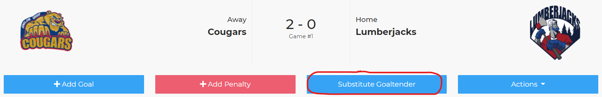

Specify the period and time on the clock:

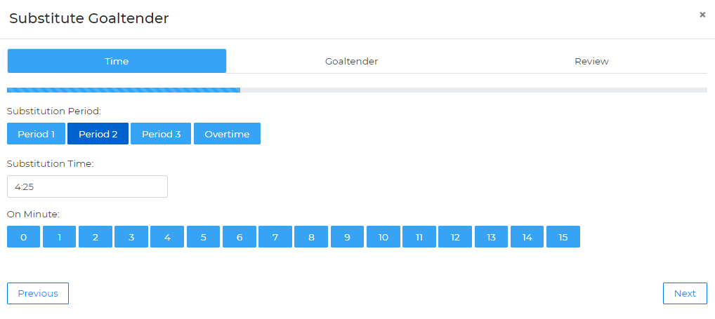

The goaltender leaving the game is highlighted by default. Specify the number of shots per period faced by the goaltender who is leaving the game, and then specify who is entering the game (the backup goaltender or an empty net), and then click Next and Finish to confirm.

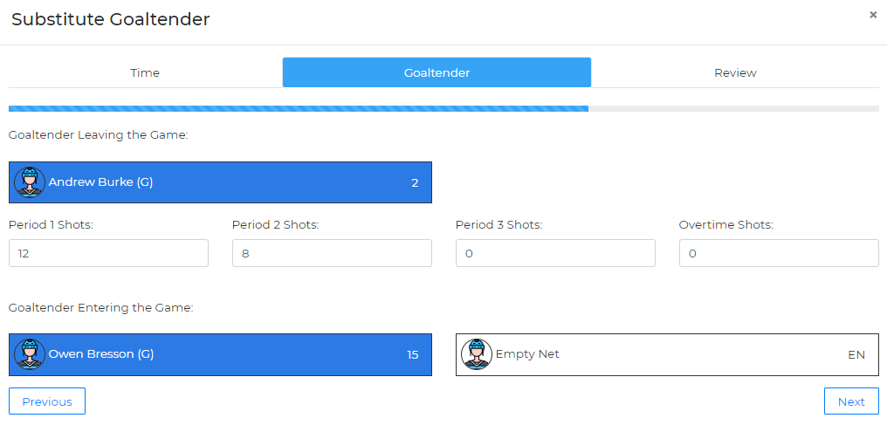

Actions Button
During game scoring, there is an Actions button which allows the timekeeper to do the following:

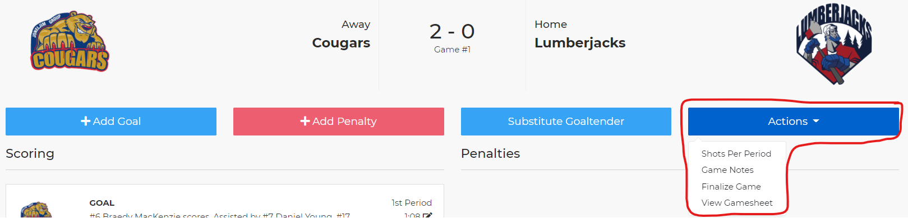

Recording Shots on Net
At the end of each period, the shots on net per team can be recorded. To properly calculate goaltender stats, this information is required. This data, combined with any goaltender substitutions, will allow us to calculate goals against average (GAA) for goaltenders.

When entering the shots on net, record the shots taken by each team. The system will assign those shots against the goaltender on the opposing team for the purposes of calculating statistics.

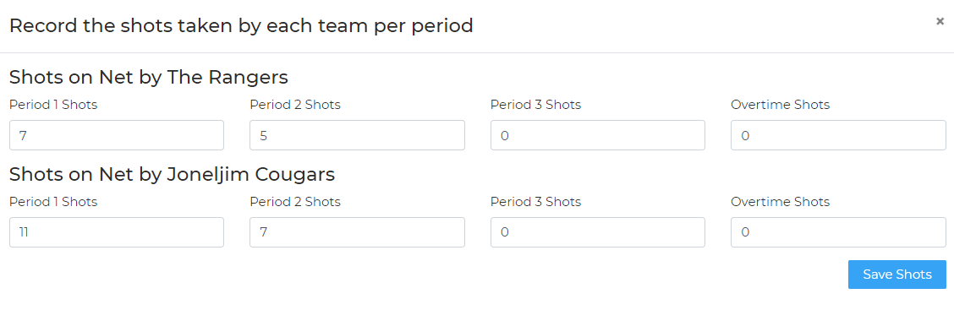

View on Website
Click View on Website to be taken to the game summary page for that game on the public website.

Shootout
If a game is going to a shootout, click Shootout in the Actions menu to record detailed results for a shootout.

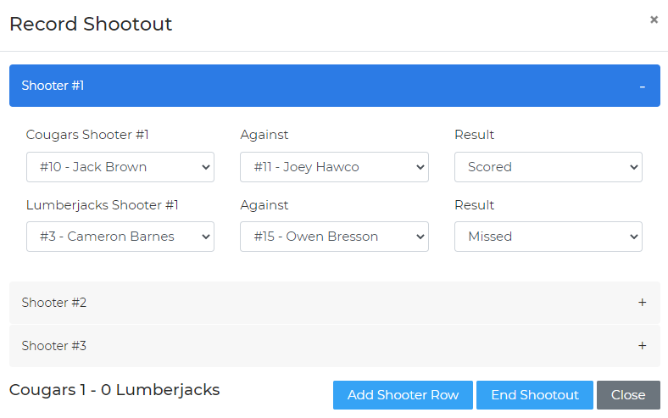

Select the shooter and goaltender for each shot, as well as the result (Scored or Missed). The score of the shootout is tracked in the lower left portion of the window. If additional shooters are required, click Add Shooter Row. When the shootout is complete, click End Shootout and the system will add a goal to the team who won the shootout. The game can then be finalized.

Finalize Game
At the completion of the game, the timekeeper will finalize the game. At this time, the winning and losing goaltenders are selected and the officials are required to sign off on the game in the system. Once the game is finalized, the result will show as “Final” on the public website. Regarding the win/loss decision for goaltenders: the goalie who was playing at the time of the winning or losing goal gets credited with the win or the loss.

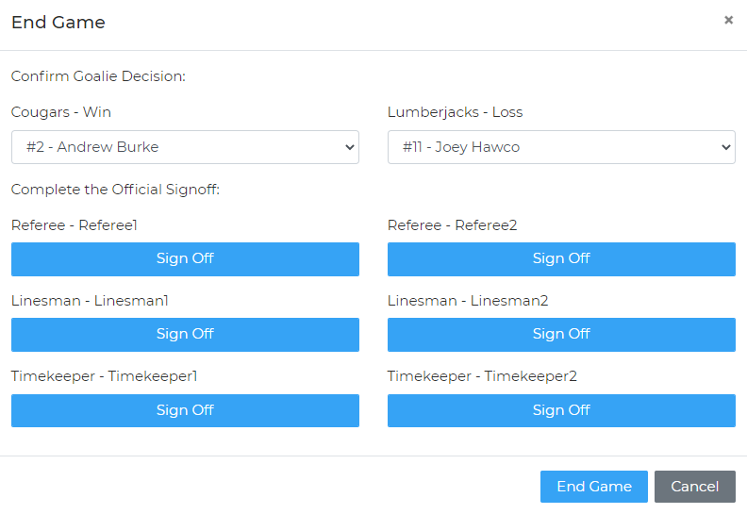

View Gamesheet
At any time during or after the game, a PDF version of the gamesheet can be viewed. This view is similar to a traditional paper gamesheet and will include all scoring details, rosters, coach and official signatures, etc..

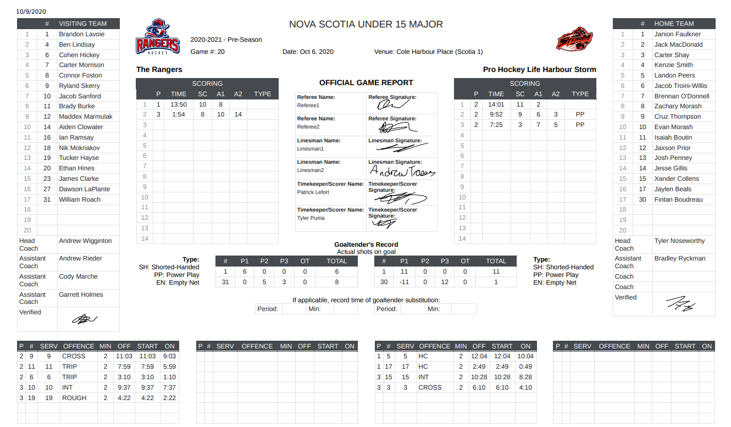

More details about pre-game tasks is included below.

Officials
The GrayJay system includes functionality for officials (referees and timekeepers) to set their availability, and for referees-in-chief to set qualifications per official. This allows the system to present available and qualified officials for each game in the system to the scheduler so he or she can assign officials to scheduled games.

The functionality described above is an optional feature, which can be disabled to allow the names of the officials to be typed in for each game. To add the names of the officials assigned to a specific game, click Officials for that game and type in the names.

The system will enforce the minimum number of officials per game as set during league setup. Mandatory fields are indicated with an asterisk.

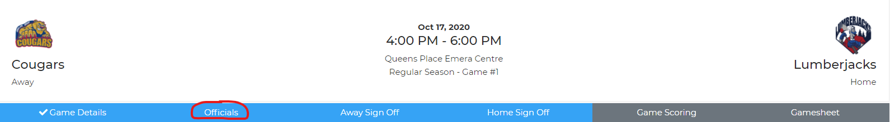
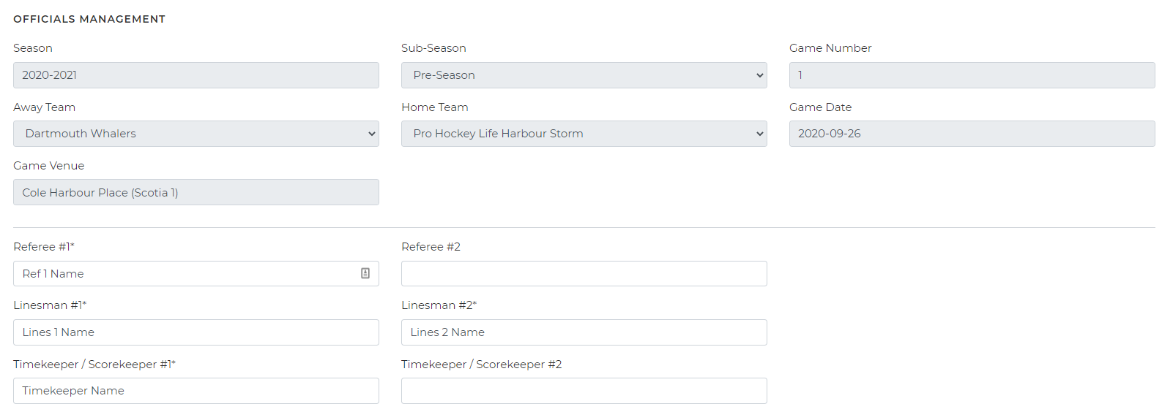

Pre-Game Team Sign Off
Before any game can be scored in the system, the roster must be specified by each team. Each team must select the Home/Away Sign Off button, at which time the full team roster will be displayed, with all players and staff selected by default to participate in the game. The system will enforce the maximum number of players per game as specified during league setup, so some players may need to be removed by tapping them. De-selected players will turn red and the total players for that game will be displayed in the top right part of the screen. You can also add or change jersey #’s for that particular game at this time, and the system will enforce unique jersey #’s per player and limit the entries to values between 1 and 99.

The same applies for coaches. Any coaches not on the bench for that game should be de-selected during the pre-game sign-off.

Finally, select the starting goaltender and click Save Roster. A team admin must then sign (using finger/stylus on a smartphone or tablet or a mouse on a computer) to confirm the roster.

